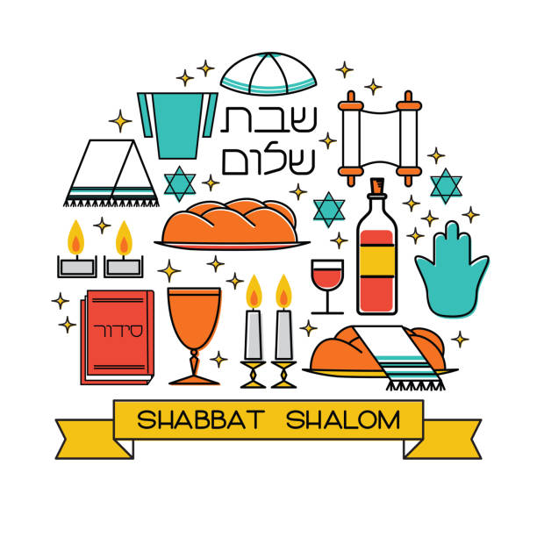
Shabbat Dinner
Friday, 21 October 2022
Join us for a Joyful Kabbalat Shabbat service at 630pm, and Dinner at 730
Santa Barbara Jewish Federation
524 Chapala Street
No Cost

